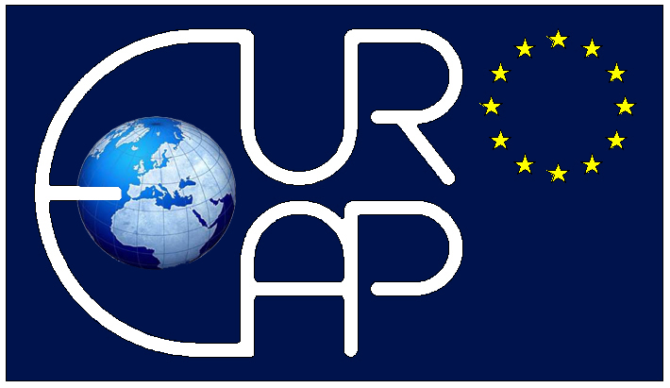
EuroEAP 2024
Twelfth international Conference on Soft Transducers and Electromechanically Active Polymers
Stuttgart, Germany, 11-13 June 2024

Title: all words except for the first one should have lowercase letters
(font: Calibri, bold, 16)
First name Last name, First name Last name, …
Company name, City, Country

Text (font: Calibri, 10) 3000 characters max

